

BSD24 Copy Range & All Range Classes / Cluster View

Business Systems Design

Author: Ian McLeod
Date: 21/08/2006

Version: 0.1

Authority: | John Wootton (Project Manager for Commercial)
Signature:
Authority:
Signature:
Authority:
Signature:
Authority:
Signature:

Contents
222223cross all Store Clusters within the Range Event on a single screen. Commercial can use this screen to range and de-range each TPNB.
M

Solution
A new view will be added to the Cluster Ranging tab called All Range Classes / Clusters.
The following metric will be available in the view and be shown by default:
Range Flag | Shows the Range Classes to which a TPNB is ranged. Allows the user to range and de-range a TPNB. | TPNB Store Cluster Range Class

Sample Screen
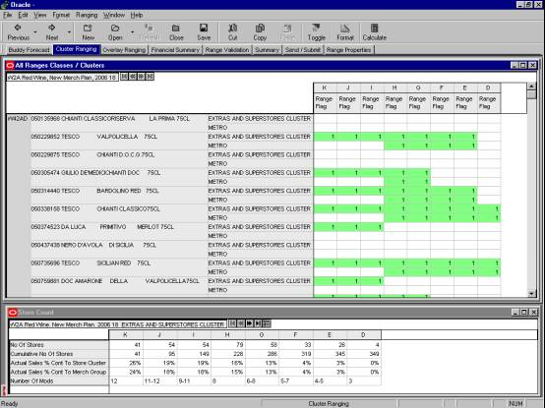
The list of TPNBs will be displayed as rows down the screen. Within each TPNB the list of Store Clusters will be displayed.
The metric will be displayed within each Range Class across the screen.

Grouping And Sorting
The list of TPNBs can be grouped using the standard available groupings (e.g. Sub Group, Brand, Tesco/Non-Tesco, etc).

Interacting With The Screen
To range a TPNB the user enters a ‘1’ in the Store Cluster / Range Class required. To de-range a TPNB the user enters a ‘0’ in the Store Cluster / Range Class required.

Copy Range View

Business Requirements Met
Commercial can copy a set of range flags and (or) overlays from one Range Class to another Range Class either within the same Store Cluster or across Store Clusters. | M

Solution
A new view will be added to the Cluster Ranging tab called Copy Range.
The following metrics will be available in the view and be shown by default:
Copy From Store Cluster | The Store Cluster to copy the range from | n/a
Copy From Range Class | The Range Class to copy the range from | n/a
Copy Type | The type of copy to perform. Either Range Flags only, Overlays only or both Range Flags and Overlays. | n/a
Copy To Store Cluster | The Store Cluster to copy the range to | n/a
Copy To Range Class | The Range Class to copy the range to | n/a
Copy Status | Notification that the copy has been performed correctly or that it could not be performed because the user has not filled in all the copy fields correctly. | n/a

Sample Screen
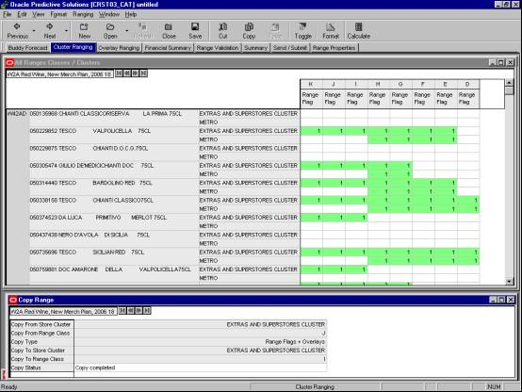

The metrics will be displayed as rows down the screen.

Interacting With The Screen
First the user selects the source Store Cluster and Range Class, the copy type and the target Range Class and Store Cluster then presses Calculate to accept the changes. Each selection is performed using a drop down list of possible values.
Once the copy has been specified the user selects ‘Copy Range’ from the Ranging menu. The copy is then performed and the Copy Status metric changes to read ‘Copy completed’. If the user has not selected all the required fields before performing the copy the Copy Status metric informs the user that all fields have not been filled in correctly.
If the user selects a copy type of ‘Range Flags’ then only range flags will be copied. If the user selects a copy type of ‘Overlays’ then only overlays will be copied. If the user selects a copy type of ‘Range Flags + Overlays’ then both range flags and overlays will be copied.

Document Control

Project: | Commercial Range Support Tool
Document Title: | BSD24 Copy Range & All Range Class Window
Document Location: | G:\Ranging\Commercial Range Support Tool\Functional Requirements\BSDs
Distribution:

Change Record
Date | Author | Change Description | Version
16/08/2006 | Ian McLeod | Initial | 0.1

